Stability Analysis Scheme for Autonomously Controlled Production Networks with Transportations
Sergey Dashkovskiy¹, Michael Görges², Lars Naujok³
¹University of Applied Sciences Erfurt, Department of Civil Engineering; sergey.dashkovski@fh-erfurt.de
²BIBA-Bremer Institut für Produktion und Logisitk GmbH at the University of Bremen; goe@biba.uni-bremen.de
³Centre for Industrial Mathematics, University of Bremen; larsnaujok@math.uni-bremen.de
Abstract In this paper we present a scheme for the stability analysis of autonomously controlled production networks with transportations. We model production networks by differential equations and discrete event simulation models (DES) from a mathematical and engineering point of view, where transportation times are considered in the models as time-delays. Lyapunov functions as a tool to check the stability of networks are used to calculate stability regions, where for parameters within this region stability is guaranteed. Then, this region is refined using the detailed DES. This approach provides a scheme to determine stability regions of networks with less time consumption in contrast to a pure simulation approach. By the existence of time-delays new challenges in the analysis occur, which is pointed out in this paper.
1 Introduction
Production networks are used to describe company or cross-company owned networks with geographically dispersed plants (Wiendahl and Lutz 2002), which are connected by transport routes. Such networks are typical examples of complex systems with a nonlinear behavior. One of the approaches to handle such complex systems is to shift from centralized to decentralized or autonomous control, i.e., to allow the plants of a network to make their own decisions based on some given rules and available local information. However, this kind of autonomous decision making causes a decentralized system behavior, which may affect the logistic performance negatively or even lead to instability of the system (Windt 2006, Philip et al. 2007).
In this paper, we consider a certain autonomously controlled production network scenario consisting of six interconnected plants focus. Here, stability of a production network means that the work in progress (WIP) remains bounded over time. Instability, by means of an unbounded growth of the WIP, may cause high inventory costs, downtimes of machines or loss of customers, for example. Hence, it is necessary for logistic systems to derive parameters, which guarantee stability.
For the analysis we provide a dual approach: a mathematical and an engineering point of view. Based on retarded functional differential equations, which abstracts a production network with transportations and includes autonomous controls, Lyapunov-Razumikhin functions (Teel 1998) are used to calculate a stability region, which includes parameters for which the network is stable (Dashkovskiy and Naujok 2010c, Dashkovskiy et al. 2010a). These stability parameters are implemented into a more detailed microscopic model, where all plants are represented by a complete shop floor. This microscopic view models the scenario with the help of a discrete event simulation (DES) tool. Using this approach the calculated stability region will be refined. The advantage is that we first apply the mathematical theory to find in a very fast way those parameters, where stability is guaranteed. Subsequently, a refinement is performed by simulations, in order to enlarge the set of parameters, which guarantee stability. This scheme provides an identification of a stability region with less time consumption in contrast to a pure simulation approach, where the time needed for the simulations increases exponentially by increasing the number of plants, parts and machines.
Existing works on stability analysis for production networks without transportations can be found in Dashkovskiy et al. (2011b), Scholz-Reiter et al. (2011a), where the mentioned scheme was firstly introduced. Here, we adopt this approach to networks with transportations using Lyapunov tools for networks presented in Dashkovskiy and Naujok (2010c) and applied in Dashkovskiy et al. (2010a), Dashkovskiy et al. (2011a), for example. However, the presence of transportations, i.e., time-delays occurs that the dynamics of the network is much more complex than the dynamics without transportations. Combined with the worst-case approach of the mathematical analysis this leads to a rough calculation of the stability region. Furthermore, the identification of stable or unstable behavior of the network using the DES for the refinement of the stability region is a challenging task and the abort criterion used in Scholz-Reiter et al. (2011a) needs to be adapted for networks with time-delays.
The paper is organized as follows: In Section 2 autonomous control methods are described. The particular scenario of a production network to be investigated is described and modeled in Section 3, where Section 3.1 contains the mathematical modeling approach and Section 3.2 the DES approach. In Section 4 the mathematical theory of the stability analysis is presented, which is applied in Section 5. The results of this application, the refinement of the identified stability region by the DES and the adaption of the abort criterion, can also be found in Section 5. Finally, Section 6 summarizes the paper.
2 Autonomously Controlled Logistic Processes
The concept of autonomous control aims at distributing decision making capabilities decentralized to single logistic objects of a system. These intelligent logistic objects can be either material objects, like parts or machines, or immaterial objects like production orders. Due to modern information and communication technology these objects are able to communicate with each other and to share information about local system states. On the basis of this information intelligent logistic objects are able to make operative decisions. In the context of production systems different autonomous control approaches focus on enabling autonomous decision making of parts. Due to a particular autonomous control method they are able to decide about routes through the system autonomously. The concept of autonomous control aims at affecting the systems performance positively and increases its robustness (Windt and Hülsmann 2007).
As far as production networks are concerned, different autonomous control methods have been developed for autonomous decision making on the network and on the shop-floor level. These autonomous control methods can be classified according to their information horizon into local information methods and information discovery methods. A description of these approaches can be found in Scholz-Reiter et al. (2011b). Local rational strategies belong to the group of local information methods. Parts using one of these methods only gather local information about states of direct succeeding buffers, machines or production plants. In Scholz-Reiter et al. (2011b), local information methods for the autonomous control of interconnected production plants were applied. It was shown that the systems performance depends on external parameters, like transport intervals or variations in the arrival rate. The results showed that depending on these parameters an autonomously controlled production network may lead to unpredictable systems states and unstable behavior. Accordingly, the stability of an autonomous controlled production network has to be investigated before starting any kind of manufacturing operations (Scholz-Reiter et al. 2011a).
In this paper the local rational autonomous control method queue length estimator (QLE) is considered for autonomous decision making on the network level and on the shop-floor level. On the shop-floor level, the QLE enables parts to choose a workstation according to local information about their current workload. In contrast, parts using this method on the network level estimate the waiting times at succeeding production plants. According to this method they will choose the next possible production plant with the shortest estimated waiting time.
3 Modeling
For the illustration of the novel stability analysis approach a particular production network has been chosen, which is described in this section.
The production network in Figure 1 consists of six geographically distributed production locations, which are connected by transportation routes. In this paper we consider the material flow between the locations, described in Figure 1 by arrows. In this scenario the IR for i = 1,…,6 represents the WIP of the i-th location at time t, where $t∈$IR₊ and IR₊ denotes all positive real values. In the rest of this paper for the i-th production location we write subsystem i. All six subsystems form the production network, which we name simply (whole) system.
Each plant of the network is represented by a complete shop floor scenario. It consists of three parallel production lines. Every line has three workstations and an input buffer in front of each workstation. The structure allows the parts to switch lines at every stage. The decision about changing the line is made by the part itself by internal control rules. This rule on the shop floor level is the QLE.
Subsystem 1 gets some raw material from an external source, denoted by IR and some material from subsystem 6. The material will be processed with a certain production rate . Then, a truck loads the processed parts and transports them to the subsystem 2or 3, according to the QLE. The transportation time from subsystem i to j is denoted by . The parts will be processed with the rates and and sent to subsystem 4 or 5, according to the QLE. After processing the parts with the rates and they will be sent to subsystem 6 and processed there with the rate . Then, 90% of the production will be delivered to some customers outside of the network and 10% of the production of subsystem 6 will be sent back to subsystem 1. This can be interpreted as recycling of the waste produced in subsystem 6, for example.
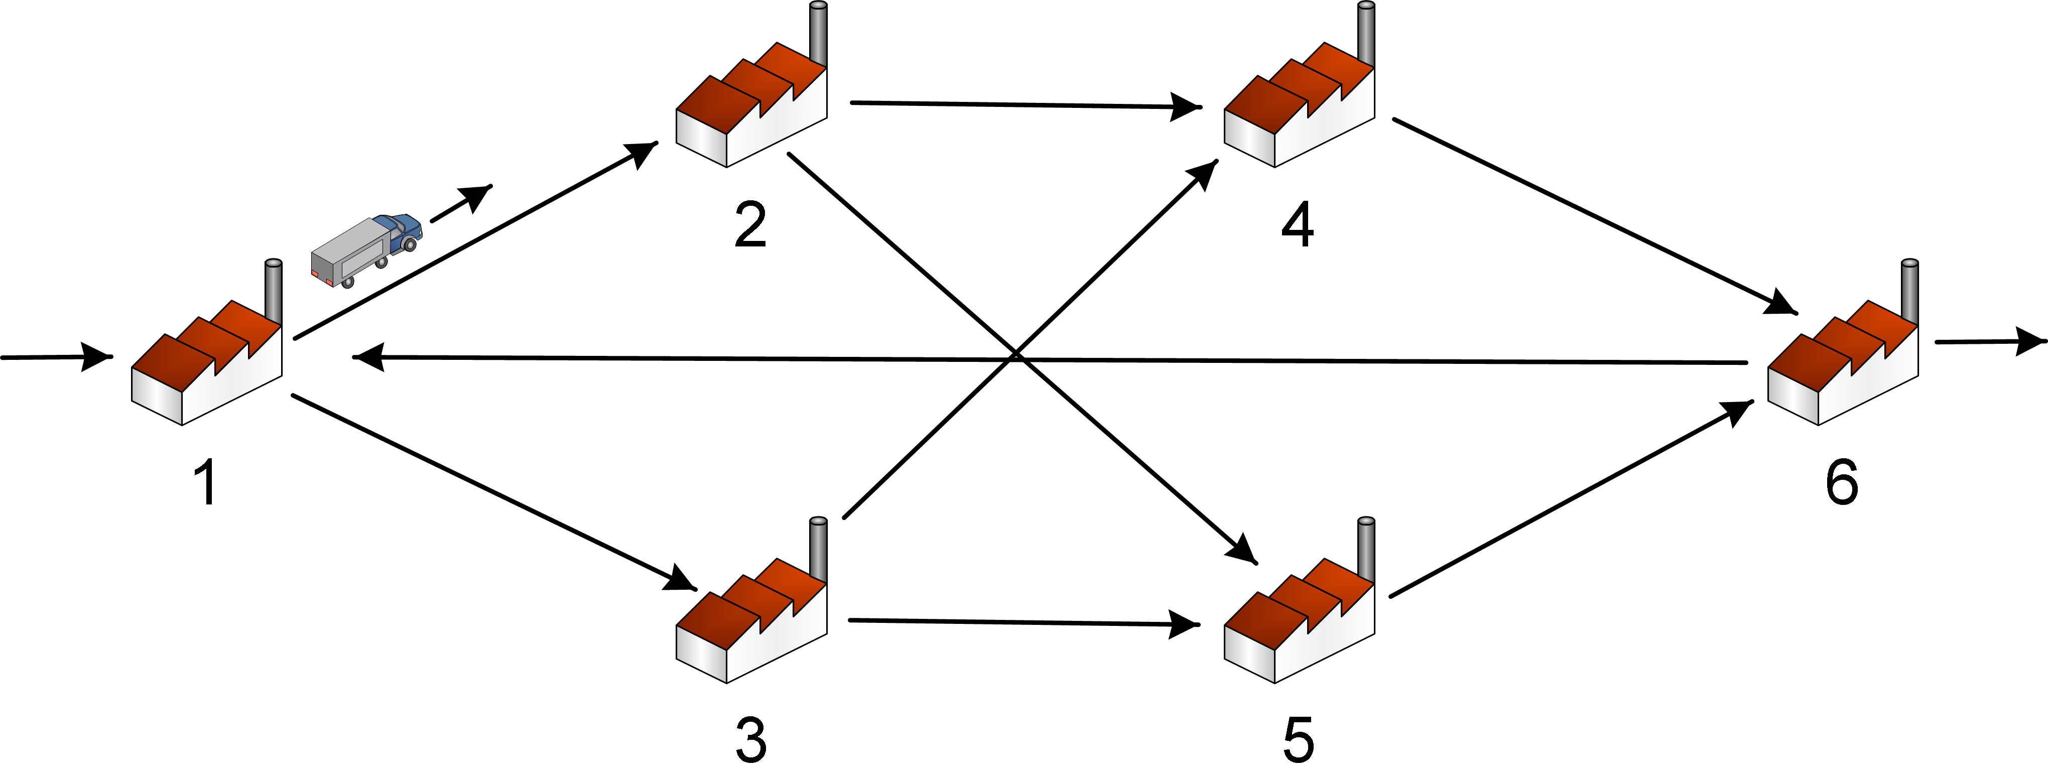
Fig. 1. The particular production network

There are two levels of aggregation and modeling. The macroscopic view focuses on the network level, which consists of production plants only. On the microscopic level, the network is represented more detailed. In addition to the macroscopic view, the microscopic view represents the plants as a set of interconnected machines. In the following these two views will be described.
3.1 Aggregated View Using ODEs
The macroscopic approach is the description and analysis from a mathematical point of view. The production network scenario is modeled by retarded functional differential equations, which are presented in this subsection.
The internal structure on the shop floor level of all subsystems is ignored. All subsystems are autonomously controlled by means of an autonomous adjustment of the production rates. According to Dashkovskiy et al. (2011b) and Scholz-Reiter et al. (2011a), the actual production rate for the subsystem i is given by
where the positive real value is the (constant) maximal production rate of the subsystem i. Note that one can choose any other rate, which fits to a certain scenario. converges to , if the WIP of the subsystem i is large and tends to zero, if the WIP of the subsystem i tends to zero. Accordingly, a huge influx of raw material causes an increase of the production rate close to the maximum, whereas less influx of raw material leads to a production rate, which is almost zero.
When modeling the system by retarded differential equations, we assume that the processed material will be transported at time t to a subsystem according to the QLE and arrives at the succeeding subsystem at the time , where can be interpreted as transportation time needed for the transportation from subsystem i to j. Here, no delay within the production process is implemented. Note that one can use variable transportation times instead of constant ones such as state- or time-dependent variables. For example, disturbances on the transport routes can be taken into account choosing variable .
A retarded differential equation describes the rate of change of the WIP along the time. In simple words this is the derivative of and it is denoted by .
With these considerations we model the given network by retarded differential equations as follows:
$\begin{aligned}{\overset{˙}{x}}_{1}(t):=u(t)+\frac{1}{\text{10}}{\tilde{f}}_{6}(x_{6}(t−τ_{\text{61}}))−{\tilde{f}}_{1}(x_{1}(t)), \\ {\overset{˙}{x}}_{2}(t):={\tilde{c}}_{\text{12}}{\tilde{f}}_{1}(x_{1}(t−τ_{\text{12}}))−{\tilde{f}}_{2}(x_{2}(t)), \\ {\overset{˙}{x}}_{3}(t):={\tilde{c}}_{\text{13}}{\tilde{f}}_{1}(x_{1}(t−τ_{\text{13}}))−{\tilde{f}}_{3}(x_{3}(t)), \\ {\overset{˙}{x}}_{4}(t):={\tilde{c}}_{\text{24}}{\tilde{f}}_{2}(x_{2}(t−τ_{\text{24}}))+{\tilde{c}}_{\text{34}}{\tilde{f}}_{3}(x_{3}(t−τ_{\text{34}}))−{\tilde{f}}_{4}(x_{4}(t)), \\ {\overset{˙}{x}}_{5}(t):={\tilde{c}}_{\text{25}}{\tilde{f}}_{2}(x_{2}(t−τ_{\text{25}}))+{\tilde{c}}_{\text{35}}{\tilde{f}}_{3}(x_{3}(t−τ_{\text{35}}))−{\tilde{f}}_{5}(x_{5}(t)), \\ {\overset{˙}{x}}_{6}(t):={\tilde{f}}_{4}(x_{4}(t−τ_{\text{46}}))+{\tilde{f}}_{5}(x_{5}(t−τ_{\text{56}}))−{\tilde{f}}_{6}(x_{6}(t)),\end{aligned}$ (1)
where represent the QLE and are given by ${\tilde{c}}_{\text{ij}}:=\frac{\frac{1}{x_{i}(t−τ_{\text{ij}})+ε}}{\frac{1}{\sum_{k}{x_{k}(t−τ_{\text{ij}})+ε}}}$
with to assure, that are well-defined. The external input is chosen according to fluctuations as $u(t):=\text{AV}(\text{sin}(t)+1)+5,$ where $\text{AV}$ is a real positive number.
For this model we perform a stability analysis from a mathematical point of view. The tools for this analysis will be described in the next section. In the context of mathematical modeling by differential equations some remarks can be stated: may also represent other relevant parameters of the system, e.g., the number of unsatisfied orders. Furthermore, one can extend or change the given production network to describe any other scenario that can be more large and complex. It is possible to perform a stability analysis for the extended system.
3.2 Detailed View Using DES
By using a DES approach, the detailed modeling is done. Due to the lower aggregation level and the discrete nature of this modeling approach some parameters from the aggregated differential equation based model have to be adjusted. The DES represents the flows of materials by discrete parts passing through the network. This requires an adjustment of the input rate in plant 1. In the DES model the arrival rate u(t) is cumulated. Whenever this cumulated arrival rate reaches an integer value a part enters the system at the corresponding time point t. A second adjustment concerns the production rates of all production plants. In the detailed view the plants represent a shop-floor scenario with 3x3 machines. Due to the parallel machines offered by the shop-floor, the production rate of a plant has to be distributed to these parallel machines. In the case at hand each work station j in the plant i has a maximal production rate of .
4 Stability Analysis
In this section, the scheme of the stability analysis is described. At first, we present the stability notion and tools for the mathematical analysis. Then, the analysis based on the DES model and the scheme for a stability analysis of production networks will be described.
We consider nonlinear dynamical systems of the form
$(2),$
which are called retarded functional differential equations (RFDE), where $x^{t}∈C([−Δ,0],R^{N})$ is defined by , where $Δ$ denotes the maximal involved delay and denotes the Banach space of continuous functions defined on $[−Δ,0]$ equipped with the norm $||x||_{[−Δ,0]}:={\text{max}}_{i}{\text{max}}_{t∈[−Δ,0]}|x_{i}(t)|$ and taking values in R^{N}. We denote the standard Euclidian norm in R^{n} by $|⋅|$ and the essential supremum norm for essentially bounded functions u in R₊ by $||u||_{∞}\text{.}$ $u∈R^{M}$ is the external input of the system, which is an essentially bounded measurable function and $f:C([−Δ,0],R^{N})×R^{M}→R^{N}$ is a nonlinear and locally Lipschitz continuous functional to guarantee that the system (1) has a unique solution for every initial condition $x_{0}=ξ$ for any $ξ∈C([−Δ,0],R^{N})$. The solution is denoted by for short. An interconnected system is described by RFDEs of the form
$(3)$
$i=\text{1,}…\text{,n,}$ where $x_{i}^{t}∈C([−Δ,0],R^{N_{i}})$, $u_{i}∈R^{M_{i}}$ and $f_{i}:C([−Δ,0],R^{N})×R^{M_{i}}→R^{N_{i}}$. If we define $x=(x_{1}^{T},\text{.}\text{.}\text{.},x_{n}^{T})^{T},$$u:=(u_{1}^{T},\text{.}\text{.}\text{.},u_{n}^{T})^{T}$ and then (3) can be written in the form (2).
Now we define local input-to-state stability (LISS) for each subsystem of (3). For system (2) the definition of LISS can be found in Dashkovskiy et al. (2010a), for example. We need some classes of functions, which can also be found in Dashkovskiy et al. (2010a).
Definition 1. The i-th subsystem of (3) is called LISS, if there exist constants and , such that for all initial functions $||ξ_{i}||_{\left[−Δ,0\right]}≤ρ_{i},$ $||x_{j}||_{[−Δ,∞)}≤ρ_{j}^{i},j≠i$ and all inputs it holds
$(4)$
$∀t∈$IR₊. $γ_{\text{ij}}$ and $γ_{i}$ are called (nonlinear) gains. Note that, if $ρ_{i},ρ_{j}^{i},ρ_{i}^{u}=∞$ then the i-th subsystem is ISS.
LISS and ISS, respectively, mean that the norm of the trajectories of each subsystem is bounded. Furthermore, we define the gain matrix $Γ:=(γ_{\text{ij}}), i,j=1,\text{.}\text{.}\text{.},n, γ_{\text{ii}}=0$, which defines a map $Γ:$IR${}_{+}^{n}$$→$IR${}_{+}^{n}$ by
IR${}_{+}^{n}$. $(5)$
To check, if the whole network has the ISS property a small gain condition is needed, which is of the form
$Γ(s)$$s, ∀s∈$IR${}_{+}^{n}$\$\left\{0\right\}$ $(6)$
Notation means that there is at least one component $i∈\left\{ 1,\text{.}\text{.}\text{.},n \right\}$ such that $Γ(s)_{i}<s_{i}\text{.}$ Here we recall a local version of the small gain condition:
Definition 2. $Γ$satisfies the local small gain condition (LSGC) on $[0,w∗]$, provided that
$Γ(w∗)<w∗$ and $Γ(s)$$s, ∀s∈[0,w∗], s≠0\text{.}$ $(7)$
Further details of (7) can be found in Dashkovskiy and Rüffer (2010b). A useful tool to verify LISS for time-delay systems are Lyapunov-Razumikhin functions (LRF) or Lyapunov-Krasovskii functionals (LKF), see (Teel 1998) and (Pepe and Jiang 2006). In this paper, we use LRF, but the analysis considering LKF is similar. For systems of the form (2) one can find the definition of LRF for example in Teel (1998) and for systems of the form (3) LRFs are defined in Dashkovskiy and Naujok (2010c). With these definitions we quote the following:
Theorem 1. Consider the interconnected system (3). Assume that each subsystem has an LISS-LRF V_{i}, $i=\text{1,}…\text{,n}$. If the corresponding gain-matrix $Γ$ satisfies the LSGC (7), then the whole system of the form (2) is LISS.
The proof can be found in Dashkovskiy and Naujok (2010c) with corresponding changes according to the LISS property. This Theorem completes the mathematical part of the stability analysis and the identification of the stability region of the network, which is the set of parameter constellations guaranteeing LISS: One has to find a LISS-LRF for each subsystem of (3) and to check if the small-gain condition (7) is satisfied. From these conditions the stability region will be identified in a first step. From Theorem 1 we know that the whole network possesses the LISS property.
In a second step the identified stability region will be refined using DES. Using LRFs and the small gain condition this leads to a rough estimation of the stability region. The DES can investigate the system and its behavior in a more detailed way. The drawback of the identification of the stability region based only of the DES approach is that one has to simulate all possible combinations of free systems variables. By a linear growth of the number of subsystems and the variables this leads to an exponential growth of time needed for the simulation runs such that a determination of the stability region in an acceptable time is not possible.
The advantage of the combination of the mathematical analysis in a first step and the DES in a second step is that the identification of the stability region using the mathematical approach is possible in a short time, where only few parameter constellations are left for investigation in view of stability. This can be performed by the DES and the stability region of networks can be identified with less time consumption in total in contrast to an approach only based on simulation runs. This is displayed in a scheme, which can be found in Scholz-Reiter et al. (2011a).
5 Stability Evaluation
In this section we determine the stability region of the certain scenario, introduced in Section 3 from a mathematical point of view and refine them using the DES.
5.1 Determining Stability Regions (math)
The stability analysis from a mathematical point of view for the certain scenario is based on the retarded differential equations, introduced in Section 3 and the tools from Section 4.
We choose $V_{i}(x_{i})=x_{i},i=1,…,6$ as the LRF candidates for the subsystems, define the Lyapunov gains for the first subsystem by
$\begin{aligned}χ_{u}(u(t)):=−\text{ln}\left(1−\frac{u(t)(||u||_{∞}+0\text{.}1⋅α_{6})}{||u||_{∞}(1−ε_{u})α_{1}}\right),1>ε_{u}>0, \\ χ_{\text{61}}(||V_{6}^{d}(x_{6})||):=−\text{ln}\left(1−\frac{||u||_{∞}+0\text{.}1⋅α_{6}}{(1−ε_{\text{61}})α_{1}}(1−\text{exp}(−||V_{6}^{d}(x_{6})||))\right),1>ε_{\text{61}}>0,\end{aligned}$ where $||V_{i}^{d}(x_{i}(t))||:={\text{max}}_{s∈[t−Δ,t]}|V(x(s))|$. The gains of the other subsystems are chosen accordingly and by similar calculations as in (Dashkovskiy and Naujok 2010c), for example, we can show that $V_{i}(x_{i})$ are the LRFs of the subsystems. This means that all subsystems are LISS, respectively. The gain-matrix consisting of $χ_{\text{ij}}$ satisfies the small-gain condition. All the calculations are skipped, because of the limited space.
To guarantee that the Lyapunov gains are well-defined we get conditions for: $α_{1}>||u||_{∞}+0\text{.}1α_{6};α_{2}>α_{1};α_{3}>α_{1};α_{4}>α_{2}+α_{3};$ $α_{5}>α_{2}+α_{3};$ $α_{6}>α_{5}+α_{4}$ from which we get that subsystem 1 is LISS with $ρ_{1}^{u}:=α_{1}−α_{6}>||u||_{∞}$. Note that these conditions are derived only for the particular scenario. For other scenarios one may get other stability conditions. Subsystems 2 to 5 are ISS. If these conditions are satisfied for any input u(t), then by Theorem 1 in Section 4 for LISS we get that the whole system is LISS, i.e., the WIP of the subsystems and therefore the WIP of the whole system is bounded. Note that the choice of the input u(t) can be arbitrary. The higher $||u||_{∞}$, the higher the maximal production rates to guarantee the fulfillment of the conditions for $α_{i}$ and to guarantee stability.
A comparison of these results with those derived in Scholz-Reiter et al. (2011a) for delay-free systems is not possible without an adaption of the scenario of a production network in the delay-free case. There, one half of the production of subsystem 6 is sent back to subsystem 1. Considering transportations and using the mathematical tools presented here, we cannot guarantee that the gains are well-defined, because the conditions for cannot be fulfilled. They can be fulfilled if less than one fourth of the production of subsystem 6 is sent back to subsystem 1.
5.2 Refining Stability Regions by Using a DES Model
In Scholz-Reiter et al. (2011a), an approach based on an abort criterion is described. This criterion defines unstable states of the network as follows: a simulation run is considered to be unstable whenever the WIP starts to grow persistently in a predefined time interval about 10% (Scholz-Reiter et al. 2011a). On the basis of this abort criterion, an approach is proposed which reduces the maximal production rate of all plants in different simulation runs in steps of 1% until the abort criterion is satisfied. The reduced maximal production rates are the results of the refinement. Due to the autonomous decision making on the network level the quantities shipped between the locations may vary. A static approach, which reduces the production rates of all plants uniformly seem not to be suitable. Thus, the approach used in this paper extends the static approach presented above. The new refinement procedure has to take into account that the shipment between plants is related to the production rates of preceding plants. Thus, the refinement procedure varies the maximal production rate of each plant separately. In order to provide a systematically refinement of the production rates an approach based on the algorithmic scheme in Figure 2 is proposed.
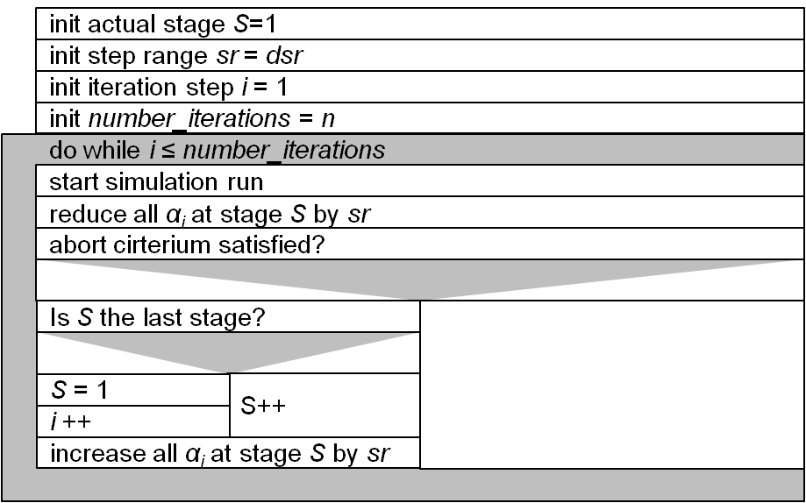
Fig. 2. Pseudo code of the refinement algorithm.
The refinement algorithm aims at finding the smallest maximal production rates for all plants guaranteeing stability. In the beginning the algorithm and its parameters are initialized. It starts with an arbitrarily network configuration, which is considered to be stable. The algorithm consists of two iterative loops. The inner iteration reduces stepwise the maximal production rates of the plants on one network stage S and starts the simulation. This iteration will be repeated until the abort criterion is satisfied. After this, the counter S is set to the next network stage and the inner loop will be repeated again, until the counter S equals the number of the last production stage. In this case the counter of the second iteration i is increased and the counter S is set again to the first network stage. The second outer iteration causes the repetition of the inner iteration until a pre-defined amount of iteration steps are reached.
5.3 Results of the Stability Analysis
We set $τ_{\text{ij}}=1$. The results of the analysis, i.e., the identification of stability regions, are the same for other values of $τ_{\text{ij}}$. Figure 3 shows the results of the mathematical stability analysis for the production plant 1 against the arrival rate amplitude variation AV. The figures for the other plants are similar. Within the mathematically identified stability region, stability of the network can be guaranteed. However, below the border of this region stable systems behavior neither can be guaranteed nor negated. In this area, the stability of the network is investigated by simulations. For the refinement of the stability region the algorithm described in Figure 2 is applied, where the calculated bounds of the stability region are the initial values. The simulated stability region of Figure 3 is the result of the refinement. The simulation model has stable behavior above the simulative derived stability border. Below this border, unstable behavior was observed.
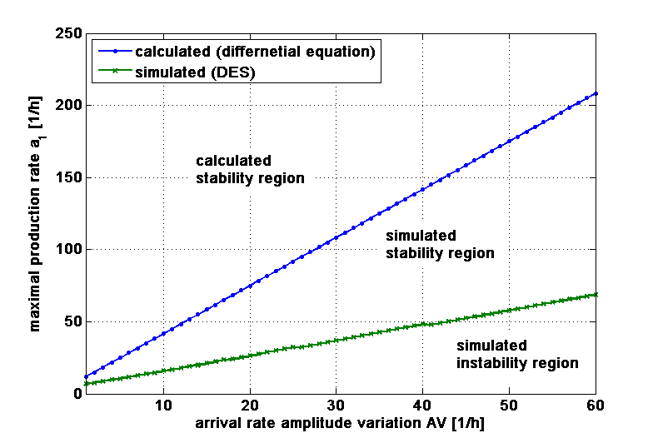
Fig. 3. Stability region of plant 1 for increasing AV.
Comparing the results of the mathematically determined and the refined stability regions, it can be noticed that gap between the mathematical and the simulated results grows with increasing AV. For AV=60, the difference between the simulated and the calculated bounds of stability is 67%. This can be explained by the usage of the worst case within the mathematical stability property ISS, namely the supremum norm. In particular, for oscillating inputs, like in the case at hand the maximal value is used to derive stability parameters. By increasing AV this leads to bigger mathematical bounds of stability. Figure 4 illustrates the results of the simulation based refinement more detailed. It depicts the WIP against time of all plants for a simulation run with AV = 4. The left column of Figure 4 shows the results for the stable situation (α₁=10.4, α₂=5.41, α₃=5.41, α₄=5.2, α₅=5.2, α₆=12.13 ). By contrast the right column shows the results of an unstable situation (α₂=4,98 and α₃=4,98). The results of the right column are determined by reducing the maximal production rates of network stage by 1%.
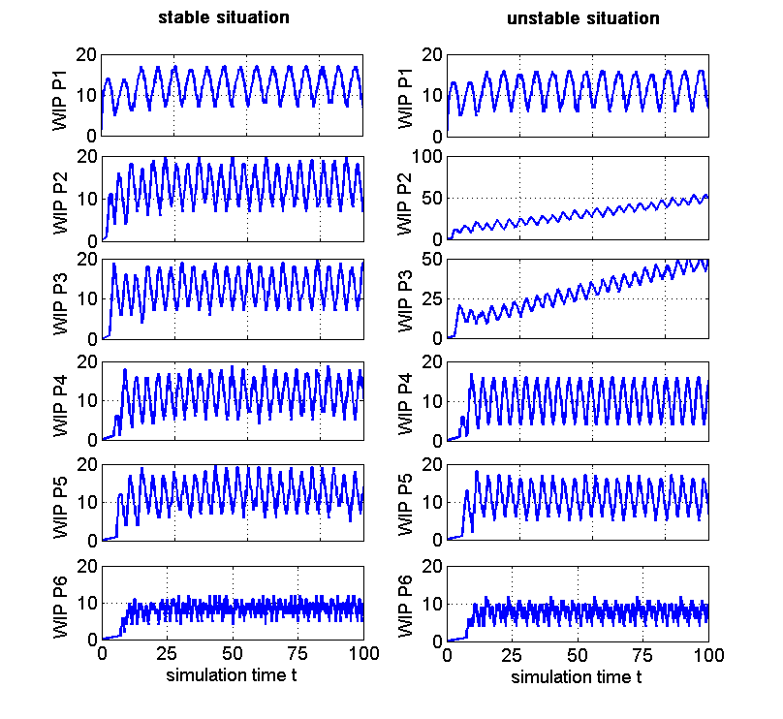
Fig. 4. Stable and unstable situation for AV = 4 .
In the unstable situation the maximal production rate of plant 2 and plant 3 is not sufficient to process the incoming material. The WIP of this plant starts to grow consequently and the network is considered to be unstable. This example shows that the mathematically determined stability region can be refined to a sharp and precise bound of stability. Note that the oscillating behavior is caused by the presence of time-delays.
Summarizing these results it shows the symbiotic character of the dual approach combining mathematical stability analysis and simulation. The simulation of the model leads to sharp and accurate stability borders. However, without a properly chosen start configuration a time intensive trial and error approach is necessary. Here the mathematical theory helps to find parameter constellations which guarantee the stability of the network. These results are used as start parameters in the simulation model. This reduces the range of possible parameters to test in the simulation approach. Accordingly, the presented stability analysis scheme can be performed more efficient compared to a trial and error approach.
6 Summary and Outlook
This paper presented an approach for the stability analysis of autonomously controlled production networks with transportations. It is based on combined methods from mathematical stability theory and from the simulation of dynamic systems. The mathematical stability analysis has been applied to an exemplarily autonomously controlled production network in order to identify parameter constellation which guarantee the stability of the entire network. In a second step these calculated stability regions were refined by using a DES model. It was shown, that the refinement leads to more precise stability results.
The approach presented in this paper focused on the QLE method for autonomous decision making in the network. Future research will focus on applying this combined approach to more complex scenarios with different autonomous control methods. The presented approach can be used for the identification of regions of effective or optimal behavior of the network in view of economic or logistic goals.
Acknowledgments This research was supported by the German Research Foundation (DFG) as part of the Collaborative Research Centre 637 “Autonomous Cooperating Logistics Processes –A Paradigm Shift and its Limitations”
References
Dashkovskiy S., Karimi H.R. Kosmykov M., Mironchenko A., Naujok L. (2010a). Application of the LISS Lyapunov-Krasovskii small-gain theorem to autonomously controlled production networks with time-delays, Proc of SysTol, Nice, France, Oct. 06-08, pp 765-770.
Dashkovskiy S. N. and Rüffer B. S. (2010b) Local ISS of large-scale interconnections and estimates for stability regions, Systems & Control Letters, 59(2010), no. 3-4, pp 241-247.
Dashkovskiy S. and. Naujok L (2010c). Lyapunov-Razumikhin and Lyapunov-Krasovskii theorems for interconnected ISS time-delay systems, Proceedings of the 19th MTNS 2010, Budapest, Hungary, July 5-9, pp 1179-1184.
Dashkovskiy S., Görges M., Kosmykov M., Mironchenko A., Naujok L. (2011a). Modeling and stability analysis of autonomously controlled production networks. Logistics Research, 3(2):145-157.
Dashkovskiy S., Görges M., Naujok L (2011b). Local input to state stability of production networks. In: Proceedings of 2nd International Conference on Dynamics in Logistics (LDIC 2009). Springer, Bremen, Germany, pp. 79-89.
Pepe P. and Jiang Z.-P. (2006). A Lyapunov-Krasovskii methodology for ISS and iISS of time-delay systems, Systems & Control Letters, 55(2006), no. 12, pp 1006-1014.
Philipp T., de Beer C., Windt K., Scholz-Reiter B. (2007). Evaluation of AutonomousLogistic Processes—Analysis of the Influence of Structural Complexity. In: Understanding Autonomous Cooperation & Control, Hülsmann, Windt. (eds), Berlin: Springer, 303–324.
Scholz-Reiter B. Dashkovskiy S., Görges M., Naujok L. (2011a). Stability analysis of autonomously controlled production networks. International Journal of Production Research, 49(16): 4857-4877.
Scholz-Reiter B., Görges M., Jagalski T. (2011b). Modeling and analyzing integrated autonomously controlled production and transport processes. Proceedings of the 21th International Conference on Production Research. ICPR 21, CD-Rom, pages 6.
Teel A.R. (1998). Connections between Razumikhin-type theorems and the ISS nonlinear small gain theorem, IEEE Trans. Automat. Control, 43(1998), no. 7, pp 960-964.
Wiendahl H.-P. and Lutz S. (2002). Production in Networks. Annals of the CIRP – Manufacturing Technology, 51(2): 1–14.
Windt K. and Hülsmann M. (2007). Changing Paradigms in Logistics - Understanding the Shift from Conventional Control to Autonomous Cooperation and Control. In: Understanding Autonomous Cooperation & Control, Hülsmann, Windt. (eds), Berlin: Springer, 4–16.
Windt K. (2006). Selbststeuerung intelligenter Objekte in der Logistik. In: M. Vec, M. Hütt and A. Freund, eds. Selbstorganisation – Ein Denksystem für Natur und Gesellschaft. Köln: Böhlau Verlag, 271-314.

