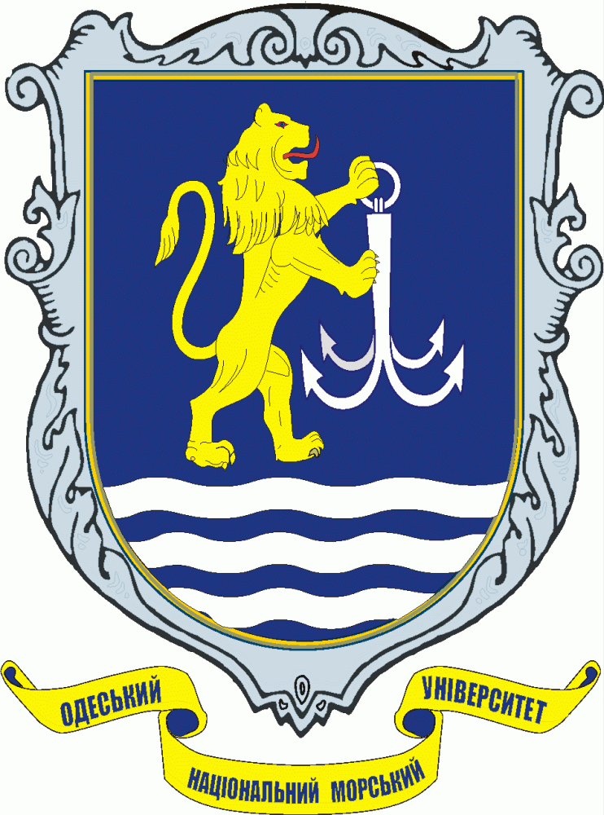

Call for Papers

3d International Scientific Conference
“Problems of Transport Logistics Development”
(Inter-TRANSLOG’2011)

September 28 - October 3, 2011
Odessa—Nesebar
Ukraine – Bulgaria

Organizers

Odessa National Maritime University
Crimean Humanitarian University
Research and Development Institute of Merchant Fleet of Ukraine (UkrNIIMF)
Transport Academy of Ukraine
Ukrainian Logistical Association
Nilkola Y. Vaptsarov Naval Academy (Bulgaria)
Bremen University (Germany)
Institute of Shipping Economics and Logistics (Germany)
West Pomeranian University of Technology (Poland)
International Academy of Ecology, Man and Nature Protection Sciences
(Ukrainian Branch)

Under Support

Ministry of Infrastructure and Tourism of Ukraine
Ministry of Education, Science, Youth and Sport of Ukraine
Odessa Regional State Administration
Shipping Company “Ukrferry”
Association “UkrPort”
Association of Ship-owners of Ukraine
Sea Commercial Port of Burgas

Scope of the Conference

Inter-TRANSLOG’2011 will provide a forum for the discussion of contemporary
problems concerning development of transport logistics and methods of their solving. The program of conference focuses on the following main topics:
- pricing in maritime logistics;
- marketing and logistics in shipping;
- practical aspects of transport/logistical chain constructing;
- projecting and functioning of distributive logistical centers nearby
the sea ports;
- supply chain management;
- perspectives of intermodal transport development in the CIS
countries;
- sea ports as elements of transport/logistical chains;
- problems of ecological logistics;
- learning and training in maritime logistics.

It is expected that participants of the Conference will be specialists from shipping companies, port authorities, forwarding companies, logistical firms, R&D Institutes of Marine Transport, and universities.

Conference site

Inter-TRANSLOG’2011 will be held on the resort Nesebar (Bulgaria)

Conference calendar

- acceptance of abstracts and registration forms - up 30.06.2011;
- 24.09.2011- departure from Odessa by bus to Nesebar;
- 25.09.2001 – arrival to Nesebar and allocation of participants in hotel;
- 26.09.2011 - opening ceremony, plenary talks from 10.00 till 16.00;
- 27.09.2011 - sessions talks (10.00-16.00);
- 28.09.2011 – sessions talks (10.00-16.00);
- 29.09.2011 – closing ceremony (10-13.00); afternoon excursion to
the Port of Burgas; conference banquet (18.00);
- 30.09.2011- departure from Nesebar to Odessa (12.00);
- 1.10.2011 – arrival to Odessa (10.00).

Languages of Conference

Official languages of the Inter-TRANSLOG’2011 are English, Russian, Ukrainian.

Abstracts

An extended abstract/short paper (up to 3 pages, 12 pt., 1.5 interval) of the paper should be submitted to the e-mail address by June 30, 2011. The title page of the abstract should contain: author’s name(s), affiliation and address, including e-mail address. The first author will receive all correspondence.
The extended abstracts for the accepted papers will be collected in a volume
distributed to all registered participants before the beginning of conference.

Payment for participation and registration

Total price for participation is 300 Euro (including the fair for bus trip from Odessa to Nesebar and back, living expenses in double occupancy room).

The registration fee is 100 US $. It may be transferred at the bank account pointed below:
Intermediary bank:
Deutsche Bank Trust Co Americas, New York
BIC: BKTRUS33
Beneficiary bank:
“SBERBANK OF RUSSIA” CJSC
(Formerly – CJSC “BANK NRB”) Kiev, Ukraine
BIC NCCJUAUK
Account number : 04421742
Beneficiary: Name Chesnokov Roman
Account number: 26200017016974

Registration fee may be paid immediately before beginning the conference
at the conference site.

Registration form:

Author’s first name(s)_____________________________________
Author’s surname(s)______________________________________
Institution______________________________________________
Affiliation_______________________________________________
Salutation_______________________________________________
Title of talk______________________________________________
________________________________________________________
________________________________________________________
Plenary or session__________________________________________
Postal address_____________________________________________
____________________________________________
E-mail ___________________________________________________
Phone____________________________________________________
Date of arrival_____________________________________________
Date of departure__________________________________________
Signature_________________________________________________

Honorary program chair:
Prof. Dr. Irina Morozova – Rector of the Odessa National Maritime University
(ONMU)

Program chair:
Prof. Dr. Anatoly Mazaraki - Head of Presidium of Scientific-Methodical
Committee on Management and Administration of
Ministry of Science, Education, Youth and Sport of
Ukraine, Rector of Kyiv National Trade-
Economical University
Co-chairs:
PhD Alexander Kurlyand – President of the Shipping Company “Ukrferry”
Mr. Gennady Skvortsov – President of Association “UkrPort”
Mr. Victor Borisenko – General Director of Association “UkrPort”
PhD Alexander Lesnik – Director of the Research and Development Institute of
Marine Fleet of Ukraine (UkrNIIMF)
PhD Maria Grygorak – President of the Ukrainian Logistical Association
Prof. Dr. Bernd Scholz-Reiter – Managing Director of the Bremen Institute for
Production and Logistics (BIBA) at the University
of Bremen, Head of the Research Center
Intelligent Production and Logistics Systems (IPS)
(Germany)
Prof. Dr. Hans-Dietrich Haasis – Director of the Institute of Shipping Economics
and Logistics (Bremen, Germany)
PC members:

PhD Sergey Rudenko – Pro-Rector of ONMU on Scientific Work
Prof. Dr. Alexei Kotlubay – Deputy Director of the Institute of Market’s Problems
and Economic-Ecological Research of the Ukrainian
National Academy of Science
PhD Alexander Balobanov – Head of the Chair “Transport Law” at ONMU
PhD Vassil Vassilev - Head of Chair “Economy, Management of Water
Transport ” at Nikola Y.Vaptsarov Naval Academy
(Bulgaria)
Prof. Dr. Vladimir Chumachenko – Dean of Department “Economy and
Management” at National Aero-cosmic University
named after N. Zhukovskii
Prof. Dr. Natal’ya Chukhray – Head of the Chair “Management of organizations”
at National University “Lvivs’ka Polytekhnika”
Prof. Dr. Sergey Dashkovskiy – Head of the Chair “Mathematical modeling of
complex systems” at the Bremen University
(Germany)
Prof. Dr. Victor Dolya – Head of the Chair “Transportation systems and logistics”
at Kharkov National Academy of City Economics
Prof. Dr. Eigen Krikavskiy - Head of the Chair “Marketing and logistics” at
National University “Lvivs’ka Polytekhnika”
Prof. Dr. Inna Lapkina – Head of the Chair “System analysis and logistics” at
ONMU
Prof . Dr. George Malindretos – Professor of the University “Harokopion”
(Athens, Greece)
Prof. Dr. Gennady Makhurenko – Head of the Chair “Economical theory and
cybernetics” at ONMU
Prof. Dr. Leonid Mirotin – Head of the Chair “Management and Applied
Logistics” at Moscow Automobile-Road Institute
(Russia)
Prof. Dr. Iouri Semenov – Head of the Chair “Logistics and economics of
transport” at the West Pomeranian University of
Technology (Poland)
Prof. PhD Alexander Sumetz – Professor of Chair “Management and military
economics” at Academy of Internal Troops, Chief
Editor of the journal “Logistics: problems and
solutions”

Organizing committee

Chair :
Prof. Dr. Mikhail Postan – Head of the Chair “Management and
Marketing” at ONMU
Co-Chair: PhD Dmitri Doykov (ONMU)

Members:
PhD Vera Baryshnikova (ONMU)
Mr. Igor Gerasimov (ONMU)
Ms. Anna Kolmykova (Germany)
Prof. PhD Alexander Leonov (ONMU)
PhD Sergey Mel’nikov (ONMU)
PhD Igor Raskevich ( Forwarding Company “Namori Ship Management”)
PhD Ninel Roszczina (ONMU)
PhD Irina Savel’eva (ONMU)
Mr. Alexander Fedorov (Association of Ship-owners of Ukraine)

Secretary: Ms. Katherine Grushevskaya (ONMU). E-mail: kate.gr@gmail.com

Mailing address for all correspondences (abstracts and registration forms):

Mrs. Vera Baryshnikova
Chair “Management and marketing”, Odessa National Maritime University,
Mechnikov Str., 34, Odessa, 65029, Ukraine
E-mail: ver.b@mail.ru
Phone: 8 050 6672592

Prof. Mikhail Postan
E-mail: postan@ukr.net
Phone: +38 067 259 47 40

Queries:
Mrs. Ninel Roszczina (+38 066 230 57 65 mob.), Vera Baryshnikova (+38 050 667 25 92 mob., +38 048 701 05 38)

